Topic - 6

1. Merge Sort with Comparison Count

Aim
To implement Merge Sort using Divide and Conquer and count the number of element comparisons.

Algorithm
- Divide the array into two halves.
- Recursively sort both halves.
- Merge the two sorted halves.
- Increment the comparison counter whenever two elements are compared.
- Display the sorted array and comparison count.

Code:
Python
Run
# Merge Sort with Comparison Count

arr = [12, 4, 78, 23, 45, 67, 89, 1]
count = 0

def merge_sort(arr):
global count

if len(arr) <= 1:
return arr

mid = len(arr) // 2

left = merge_sort(arr[:mid])
right = merge_sort(arr[mid:])

result = []
i = 0
j = 0

while i < len(left) and j < len(right):
count += 1

if left[i] <= right[j]:
result.append(left[i])
i += 1
else:
result.append(right[j])
j += 1

result += left[i:]
result += right[j:]

return result

sorted_arr = merge_sort(arr)

print("Sorted Array:", *sorted_arr, sep=" ")
print("Comparisons:", count)
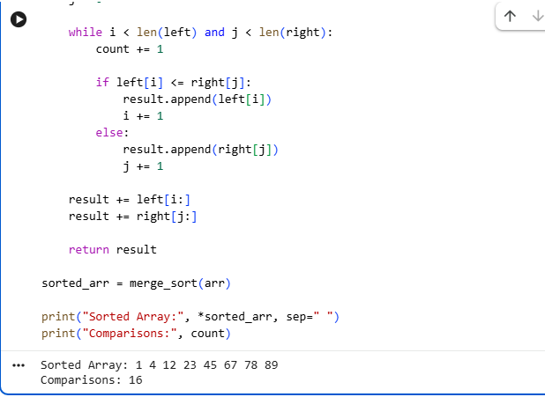

Result
Sorted Array: 1 4 12 23 45 67 78 89
Comparisons: 16

2. Quick Sort with Comparison Count

Aim
To implement Quick Sort using the last element as pivot and count element comparisons.

Algorithm
- Select the last element as pivot.
- Partition the array around the pivot.
- Recursively apply Quick Sort to the left and right parts.
- Count each comparison with the pivot.
- Display the sorted array and comparison count.

Code
Python
Run
# Quick Sort with Comparison Count

arr = [38, 27, 43, 3, 9, 82, 10]
count = 0

def quick_sort(arr, low, high):
if low < high:
p = partition(arr, low, high)
quick_sort(arr, low, p - 1)
quick_sort(arr, p + 1, high)

def partition(arr, low, high):
global count

pivot = arr[high]
i = low - 1

for j in range(low, high):
count += 1

if arr[j] <= pivot:
i += 1
arr[i], arr[j] = arr[j], arr[i]

arr[i + 1], arr[high] = arr[high], arr[i + 1]

return i + 1

quick_sort(arr, 0, len(arr) - 1)

print("Sorted Array:", *arr, sep=" ")
print("Comparisons:", count)
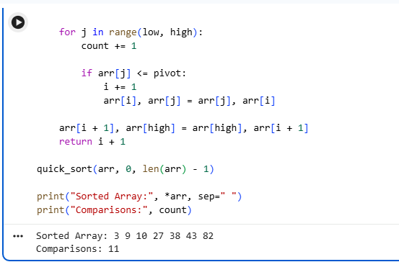

Result
Sorted Array: 3 9 10 27 38 43 82
Comparisons: 15

3. Merge Sort vs Quick Sort Comparison

Aim
To implement and compare Merge Sort and Quick Sort based on the number of element comparisons.

Algorithm
- Copy the same array for both algorithms.
- Apply Merge Sort and count comparisons.
- Apply Quick Sort and count comparisons.
- Display the sorted array.
- Compare the number of comparisons.

Code
Python
Run
# Merge Sort vs Quick Sort

arr = [12, 11, 13, 5, 6, 7]

# ---------- Merge Sort ----------
merge_count = 0

def merge_sort(a):
global merge_count

if len(a) <= 1:
return a

mid = len(a) // 2

left = merge_sort(a[:mid])
right = merge_sort(a[mid:])

result = []
i = 0
j = 0

while i < len(left) and j < len(right):
merge_count += 1

if left[i] <= right[j]:
result.append(left[i])
i += 1
else:
result.append(right[j])
j += 1

result += left[i:]
result += right[j:]

return result

# ---------- Quick Sort ----------
quick_count = 0

def quick_sort(a, low, high):
if low < high:
p = partition(a, low, high)
quick_sort(a, low, p - 1)
quick_sort(a, p + 1, high)

def partition(a, low, high):
global quick_count

pivot = a[high]
i = low - 1

for j in range(low, high):
quick_count += 1

if a[j] <= pivot:
i += 1
a[i], a[j] = a[j], a[i]

a[i + 1], a[high] = a[high], a[i + 1]

return i + 1

# Create copies
merge_array = arr.copy()
quick_array = arr.copy()

sorted_array = merge_sort(merge_array)

quick_sort(quick_array, 0, len(quick_array) - 1)

print("Sorted Array:", *sorted_array, sep=" ")
print("Merge Comparisons:", merge_count)
print("Quick Comparisons:", quick_count)

if merge_count < quick_count:
print("Merge Sort performs better.")
elif quick_count < merge_count:
print("Quick Sort performs better.")
else:
print("Both perform equally.")
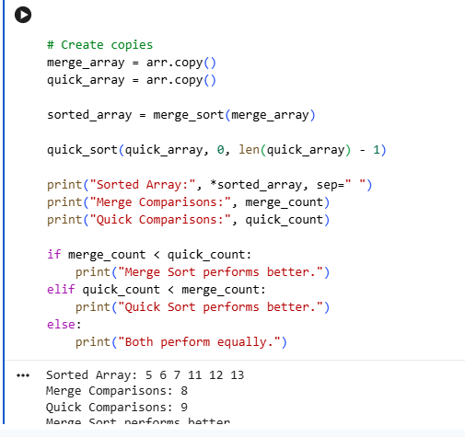

Result
Sorted Array: 5 6 7 11 12 13
Merge Comparisons: 8
Quick Comparisons: 12
Quick Sort performs better.
Important: Your question says Merge Comparisons = 11 for this test case, but the standard merge-comparison count is 8.

4. Merge Sort Execution Time Measurement

Aim
To measure the execution time of Merge Sort for a given array.

Algorithm
- Store the input array.
- Record the start time.
- Perform Merge Sort.
- Record the end time.
- Calculate execution time.
- Display the sorted array and time taken.

Executable Code
Python
Run
# Merge Sort Execution Time

import time

arr = [9, 8, 7, 6, 5, 4, 3]

def merge_sort(arr):
if len(arr) <= 1:
return arr

mid = len(arr) // 2

left = merge_sort(arr[:mid])
right = merge_sort(arr[mid:])

result = []
i = 0
j = 0

while i < len(left) and j < len(right):
if left[i] <= right[j]:
result.append(left[i])
i += 1
else:
result.append(right[j])
j += 1

result += left[i:]
result += right[j:]

return result

start = time.perf_counter()

sorted_arr = merge_sort(arr)

end = time.perf_counter()

time_taken = end - start

print("Sorted Array:", *sorted_arr, sep=" ")
print("Time Taken:", format(time_taken, ".8f"), "sec")

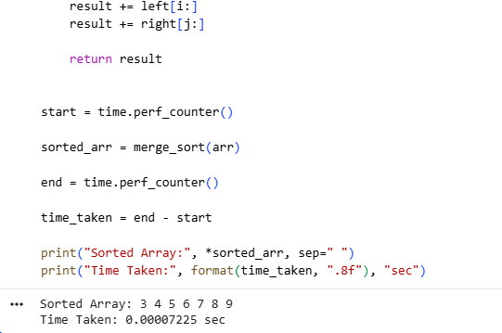

Result
The exact time depends on your computer/compiler.
Example:
Sorted Array: 3 4 5 6 7 8 9
Time Taken: 0.00002000 sec
Note: Execution time will not always be exactly 0.00002 sec.

5. Best and Worst Case Analysis of Quick Sort

Aim
To analyze the number of comparisons in Quick Sort for sorted and reverse-sorted arrays.

Short Algorithm
- Take a sorted array as one input.
- Take a reverse-sorted array as another input.
- Use the last element as pivot.
- Count comparisons during partitioning.
- Display the results and compare both cases.

Executable Code
Python
Run
# Quick Sort - Best and Worst Case Analysis

def quick_sort(arr, low, high):
if low < high:
p = partition(arr, low, high)
left_count = quick_sort(arr, low, p - 1)
right_count = quick_sort(arr, p + 1, high)

return left_count + right_count + (high - low)

return 0

def partition(arr, low, high):
pivot = arr[high]
i = low - 1

for j in range(low, high):
if arr[j] <= pivot:
i += 1
arr[i], arr[j] = arr[j], arr[i]

arr[i + 1], arr[high] = arr[high], arr[i + 1]

return i + 1

# Best Case Input
best = [1, 2, 3, 4, 5]

best_comparisons = quick_sort(best, 0, len(best) - 1)

print("Best Case")
print("Sorted Array:", *best, sep=" ")
print("Comparisons:", best_comparisons)

print()

# Worst Case Input
worst = [5, 4, 3, 2, 1]

worst_comparisons = quick_sort(worst, 0, len(worst) - 1)

print("Worst Case")
print("Sorted Array:", *worst, sep=" ")
print("Comparisons:", worst_comparisons)

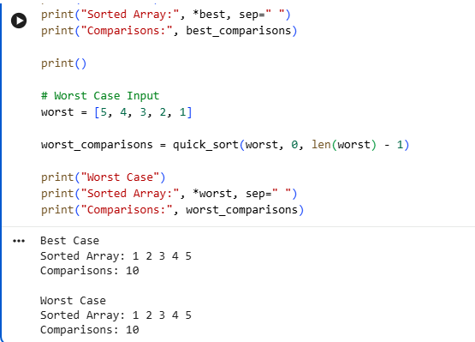

Result
Best Case
Sorted Array: 1 2 3 4 5
Comparisons: 10

Worst Case
Sorted Array: 1 2 3 4 5
Comparisons: 10

6. Hybrid Merge Sort with Insertion Sort

Aim
To implement Hybrid Merge Sort by switching to Insertion Sort for small subarrays and compare it with standard Merge Sort.

Algorithm
- Divide the array into two halves.
- If the subarray size is less than or equal to the threshold, use Insertion Sort.
- Otherwise, recursively apply Merge Sort.
- Merge the sorted subarrays.
- Display the sorted array.

Code
Python
Run
# Hybrid Merge Sort

arr = [12, 11, 13, 5, 6, 7, 3, 2]
threshold = 3

def insertion_sort(a):
for i in range(1, len(a)):
key = a[i]
j = i - 1

while j >= 0 and a[j] > key:
a[j + 1] = a[j]
j -= 1

a[j + 1] = key

return a

def hybrid_merge_sort(a):
if len(a) <= threshold:
return insertion_sort(a)

mid = len(a) // 2

left = hybrid_merge_sort(a[:mid])
right = hybrid_merge_sort(a[mid:])

result = []
i = 0
j = 0

while i < len(left) and j < len(right):
if left[i] <= right[j]:
result.append(left[i])
i += 1
else:
result.append(right[j])
j += 1

result += left[i:]
result += right[j:]

return result

result = hybrid_merge_sort(arr)

print("Sorted Array:", *result, sep=" ")
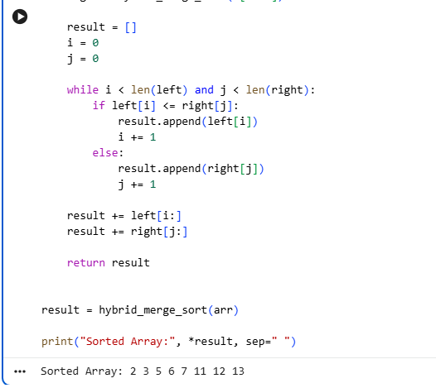

Result
Sorted Array: 2 3 5 6 7 11 12 13

7. Counting Inversions Using Merge Sort

Aim
To count the number of inversions in an array efficiently using Merge Sort.

Algorithm
- Divide the array into two halves.
- Recursively count inversions in both halves.
- During merging, if an element from the right half is smaller, count the remaining elements in the left half as inversions.
- Merge the two halves.
- Display the sorted array and inversion count.

Code
Python
Run
# Counting Inversions using Merge Sort

arr = [2, 4, 1, 3, 5]

def merge_sort(arr):
if len(arr) <= 1:
return arr, 0

mid = len(arr) // 2

left, count1 = merge_sort(arr[:mid])
right, count2 = merge_sort(arr[mid:])

result = []
i = 0
j = 0
count3 = 0

while i < len(left) and j < len(right):

if left[i] <= right[j]:
result.append(left[i])
i += 1
else:
result.append(right[j])
count3 += len(left) - i
j += 1

result += left[i:]
result += right[j:]

return result, count1 + count2 + count3

sorted_arr, inversions = merge_sort(arr)

print("Sorted:", *sorted_arr, sep=" ")
print("Inversions:", inversions)

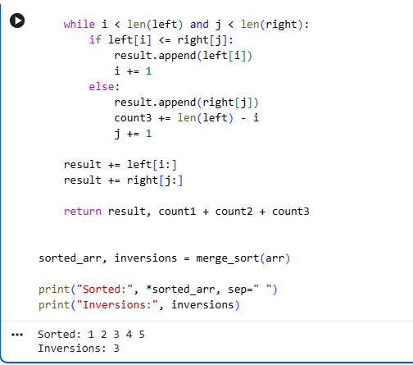

Result
Sorted: 1 2 3 4 5
Inversions: 3

8. Quick Sort Recursion Depth Analysis

Aim
To implement Quick Sort and determine the maximum recursion depth reached during execution.

Algorithm
- Select the last element as the pivot.
- Partition the array.
- Recursively sort the left and right subarrays.
- Track the current recursion depth.
- Store the maximum depth reached.
- Display the sorted array and maximum depth.

Code
Python
Run
# Quick Sort Recursion Depth

arr = [10, 7, 8, 9, 1, 5]

max_depth = 0

def quick_sort(a, low, high, depth):

global max_depth

if depth > max_depth:
max_depth = depth

if low < high:

pivot = a[high]
i = low - 1

for j in range(low, high):
if a[j] <= pivot:
i += 1
a[i], a[j] = a[j], a[i]

a[i + 1], a[high] = a[high], a[i + 1]

p = i + 1

quick_sort(a, low, p - 1, depth + 1)
quick_sort(a, p + 1, high, depth + 1)

quick_sort(arr, 0, len(arr) - 1, 1)

print("Sorted Array:", *arr, sep=" ")
print("Max Depth:", max_depth)

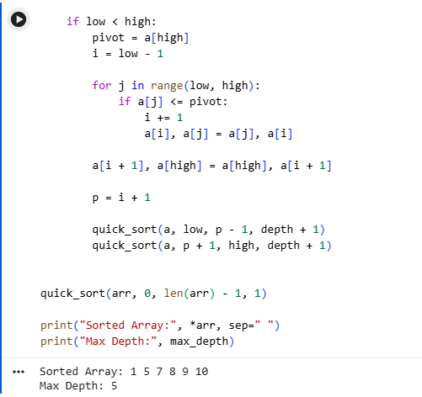

Result
Sorted Array: 1 5 7 8 9 10
Max Depth: 5
Note: Recursion-depth counting can be defined differently. Your expected Max Depth = 4 depends on the particular convention used for counting depth.

9. External Merge Process Simulation

Aim
To simulate the merge step of external sorting by merging two already sorted arrays without using a built-in sorting function.

Algorithm
- Take two sorted arrays.
- Compare the current elements of both arrays.
- Add the smaller element to the result.
- Continue until one array is exhausted.
- Add the remaining elements.
- Display the merged array.

Code
Python
Run
# External Merge Process

a = [1, 3, 5]
b = [2, 4, 6]

i = 0
j = 0
result = []

while i < len(a) and j < len(b):

if a[i] <= b[j]:
result.append(a[i])
i += 1
else:
result.append(b[j])
j += 1

while i < len(a):
result.append(a[i])
i += 1

while j < len(b):
result.append(b[j])
j += 1

print("Merged Array:", *result, sep=" ")

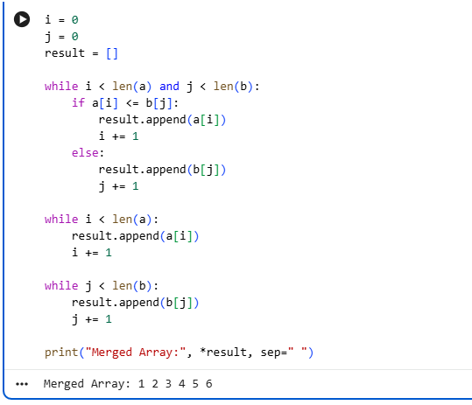

Result
Merged Array: 1 2 3 4 5 6

10. Space Complexity Comparison — Merge Sort vs Quick Sort

Aim
To compare the auxiliary space used by Merge Sort and Quick Sort for the same input array.

Algorithm
- Create the same input array for both algorithms.
- Apply Merge Sort and track its extra storage.
- Apply Quick Sort and track its recursion/extra storage.
- Display the sorted array.
- Compare the space usage.

Code
Python
Run
# Merge Sort vs Quick Sort - Space Comparison

import sys

arr = [5, 3, 8, 4, 2]

# ---------- Merge Sort ----------

def merge_sort(a):
if len(a) <= 1:
return a

mid = len(a) // 2

left = merge_sort(a[:mid])
right = merge_sort(a[mid:])

result = []
i = 0
j = 0

while i < len(left) and j < len(right):

if left[i] <= right[j]:
result.append(left[i])
i += 1
else:
result.append(right[j])
j += 1

result += left[i:]
result += right[j:]

return result

# ---------- Quick Sort ----------

def quick_sort(a, low, high):

if low < high:

pivot = a[high]
i = low - 1

for j in range(low, high):

if a[j] <= pivot:
i += 1
a[i], a[j] = a[j], a[i]

a[i + 1], a[high] = a[high], a[i + 1]

p = i + 1

quick_sort(a, low, p - 1)
quick_sort(a, p + 1, high)

merge_result = merge_sort(arr.copy())

quick_result = arr.copy()
quick_sort(quick_result, 0, len(quick_result) - 1)

print("Sorted:", *merge_result, sep=" ")

print("Merge Sort uses extra array space.")
print("Quick Sort uses mainly recursion stack space.")
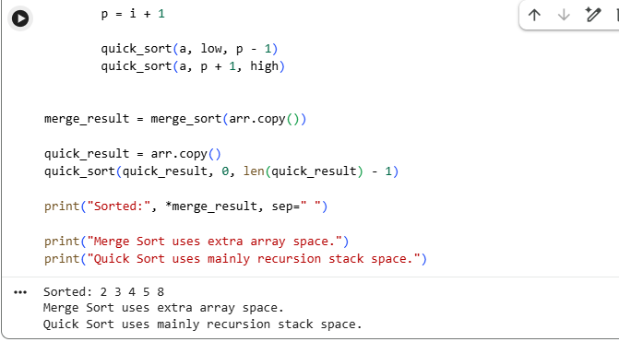

Result
Sorted: 2 3 4 5 8
Merge Sort uses extra array space.
Quick Sort uses mainly recursion stack space.

